How to Enter Billing with Service Delivery in WellSky

Get to the Main Menu in WellSky
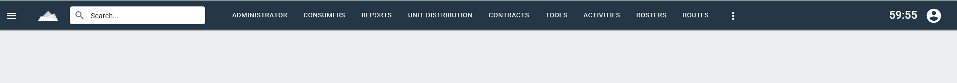

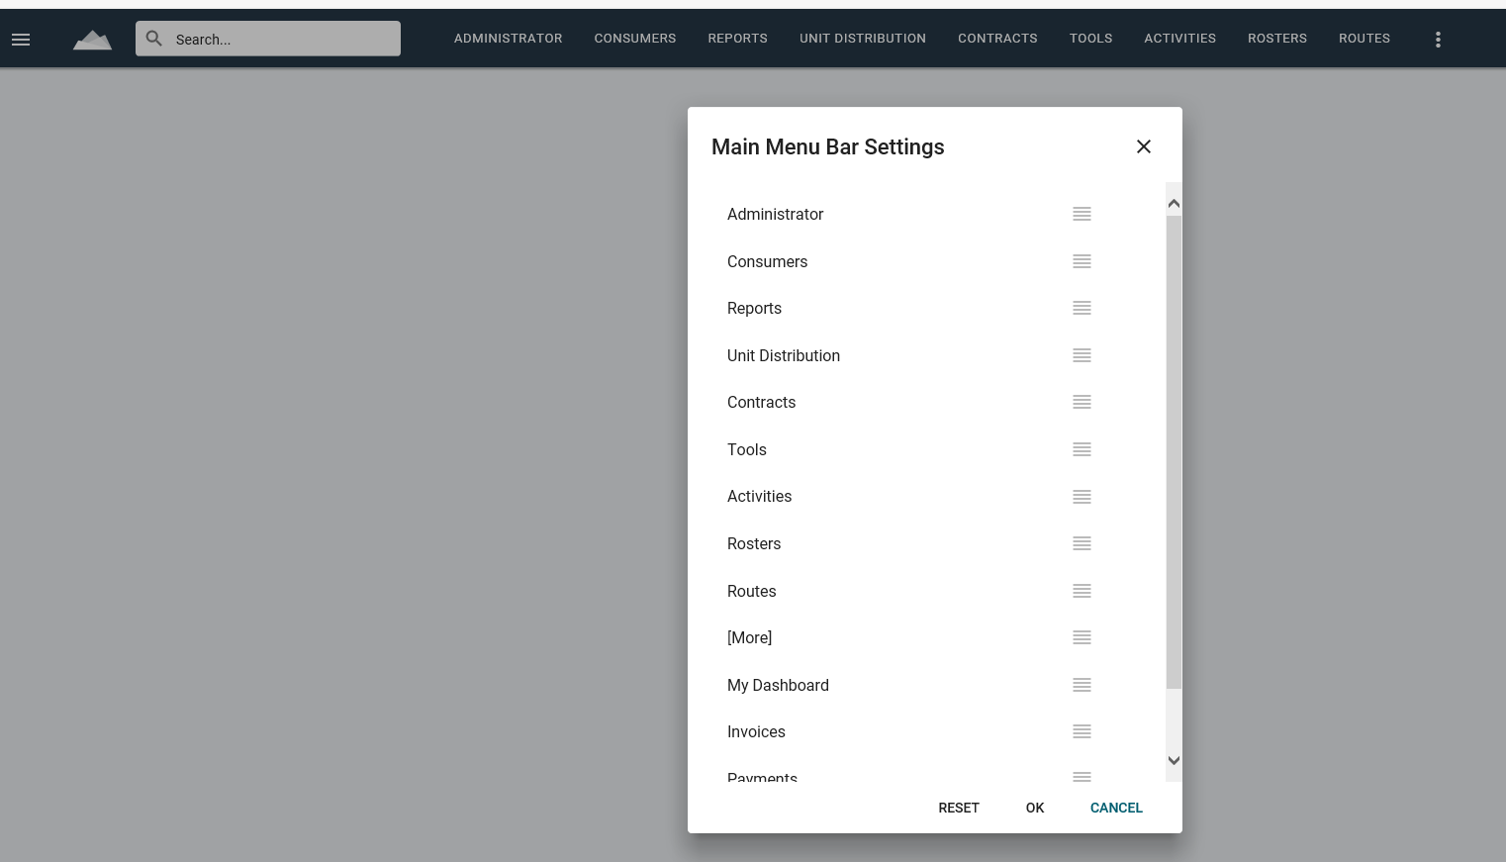
Use drop down to rearrange Main Menu if needed.

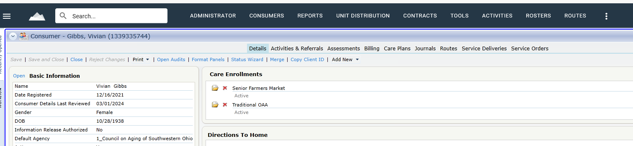
In Search Box enter name or WellSky Client number.
Click on Service Deliveries

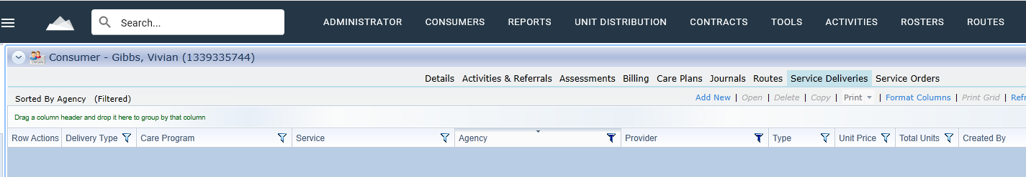
Click on Add New
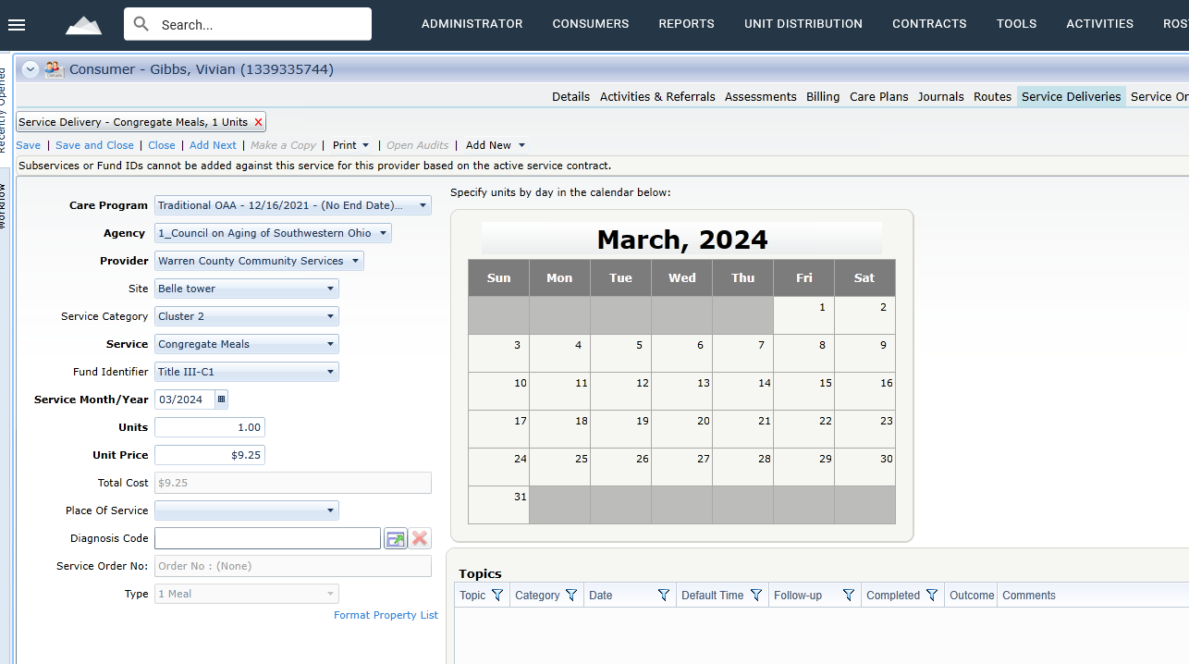
Enter Items needed, Save and Close
Done

Next time for this client
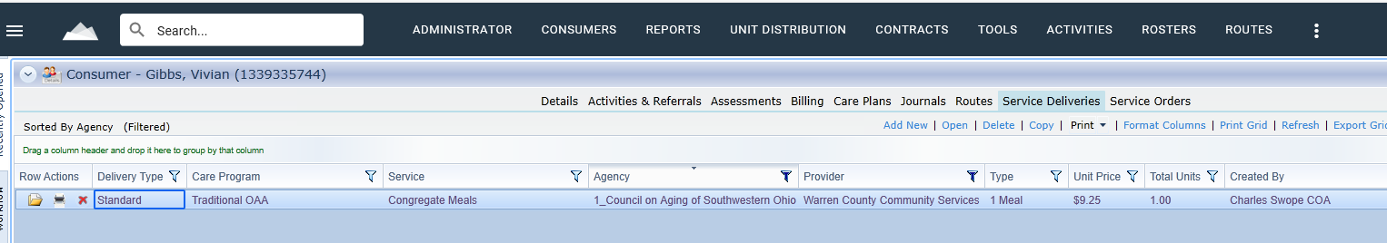
Highlight the service delivery and click Copy

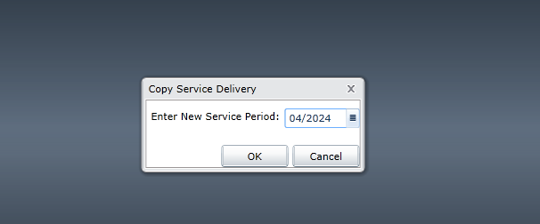
Choose correct service to be billed

Enter Items needed, Save and Close
Done

